

**NORTHFIELD PUBLIC SCHOOLS**

**TIME CLOCK PLUS HANDBOOK**

**VERSION 7.0**

**SEPTEMBER 2016**

**Program Administrator**

**Val Mertesdorf | 507.663.0620 |** [**vmertesdorf@northfieldschools.org**](mailto:vmertesdorf@northfieldschools.org)

**Payroll Specialist**

**Mary Czech | 507.663.0628 |** [**mczech@northfieldschools.org**](mailto:mczech@northfieldschools.org)

[**Payroll Deadlines**](https://northfieldschools.org/files/2017-18-PAYROLL-CALENDAR-REVISED-website.pdf)

**Table of Contents**

**PROXY READER** | **WEBCLOCK** **|** **SPLIT SEGMENTS** **|** **ADDING NOTES** **|** **MANAGE TIME SHEET**

**CORRECTING ERRORS** **|** **APPROVING SEGMENTS** | **MISSED PUNCH**

**PROXY READER (WALL CLOCK)**

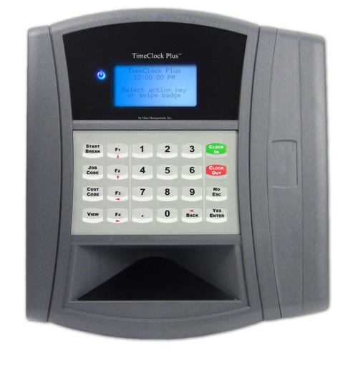

**Proximity Reader**

**Clock In | Clock Out**

**Change job code**

1. Push “Clock In”
2. Wave badge in front of proximity reader (right hand side)
3. Select Job Code if applicable (use up and down arrows (F1 | F2) to see description)
4. Push “Yes Enter”
5. To clock out, push “Clock Out” and wave badge in front of proximity reader

**WEBCLOCK**

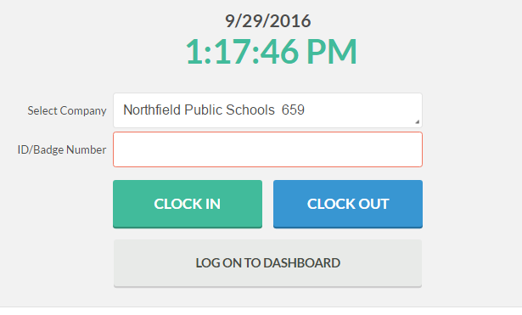

**-View Hours**

**-Approve Segments**

**-Add Leave**

**-Split Segments**

**-Add Notes**

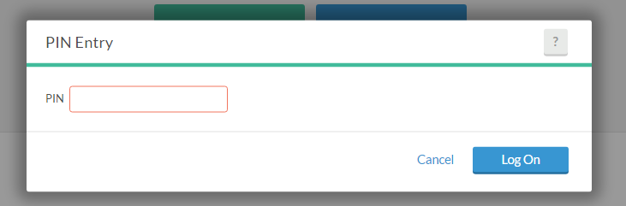

**Please note: Staff can access Time Clock from home. It is appropriate to add leave or approve time if needed. It is NOT acceptable to punch in or out from home or another mobile device unless you receive specific authority to do so. The location of your punch is tracked and reviewed periodically. Inappropriate use could result in disciplinary action.**

**SPLIT SEGMENTS**

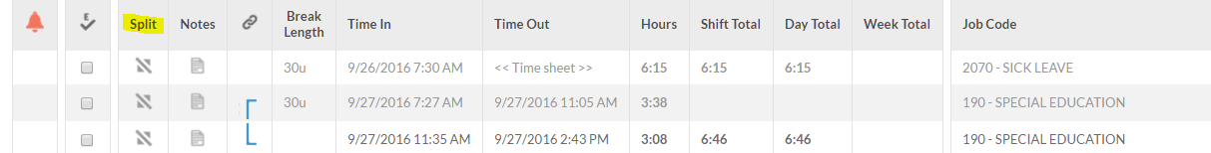

**Click gray split button**

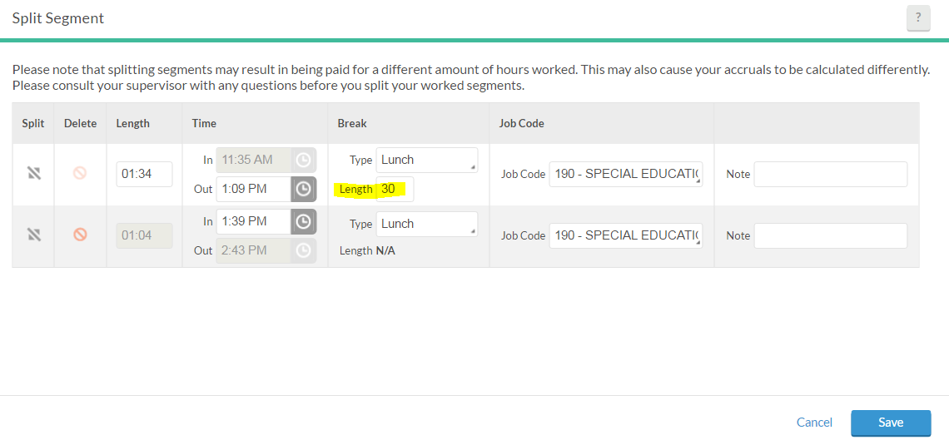

Click the gray split button to add additional segments. If you are splitting to deduct lunch, you have to enter the number of minutes in the length box. This will automatically change the “in” time for the second segment. If you are splitting to change job codes, leave the length at 0 and enter the “out” time on the first line – this will automatically update the “in” time on the second line. You can change the job code via the drop down and add notes if needed. Click SAVE!

**ADDING NOTES**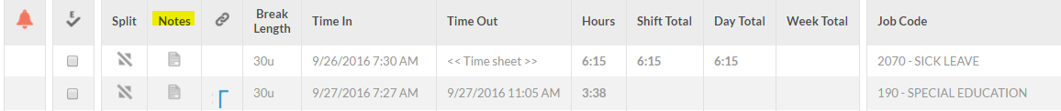

**Click gray note button**

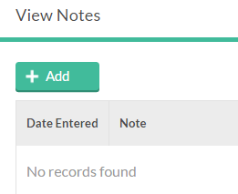

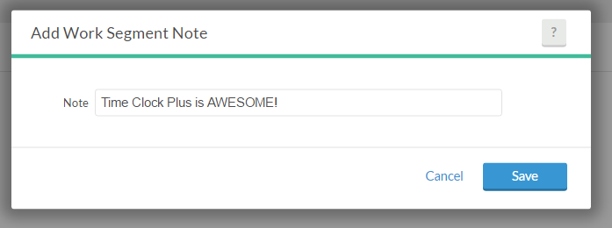

**MANAGE TIME SHEET**

**Use manage time sheet to add leave, holidays or manually add segments if that is authorized for your job code. Staff can now ADD, DELETE and CHANGE manually entered segments themselves. Please note, this DOES NOT mean you can manually add your regularly clocked hours – this only applies to leave codes and job codes that are authorized for manual entry.**

**\*\*\* You can only enter segments for up to 7 days in the past, please make an effort to do this weekly now \*\*\***

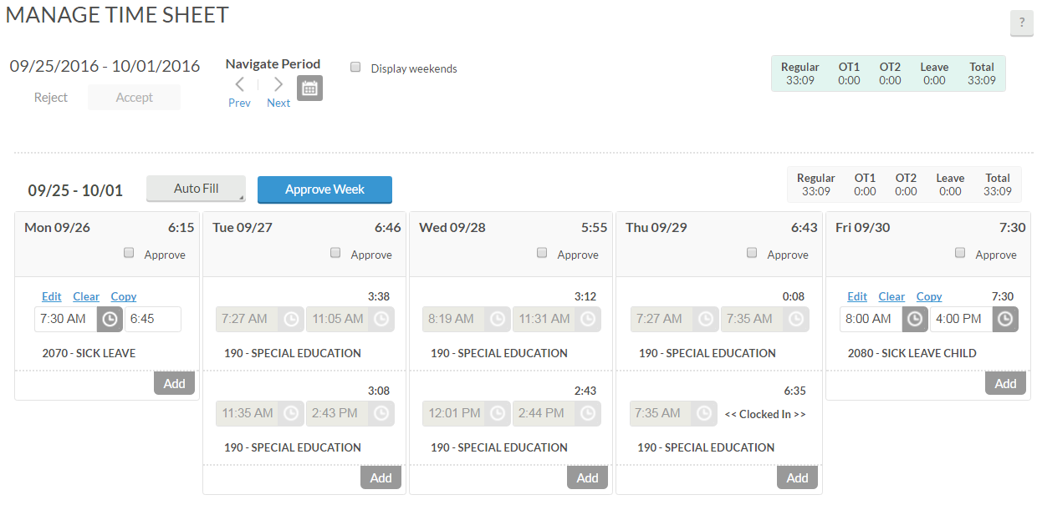

**Click Add under the appropriate day of the week. If you need Saturday and Sunday, click the box that says “Display Weekends”**

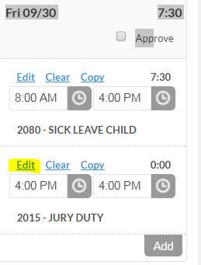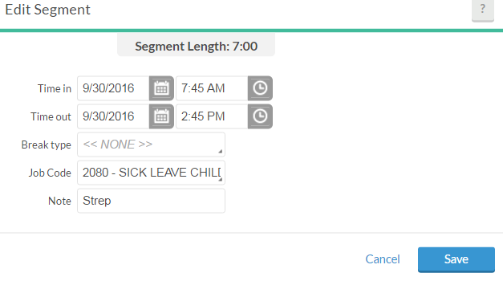

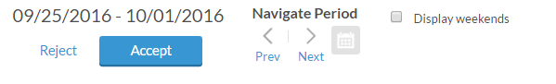

**You must click Accept for it to save your changes!**

**If you entered something incorrectly, you can edit or delete it for 7 days after the date. This is a welcome new feature! Always remember to click Accept to finalize changes each time.**

**Most leave codes will automatically deduct 30 minutes for lunch, please enter your entire scheduled time. (i.e. 7:30-2:45 = 6.75 paid hours)**

**\*\*\* Once your Supervisor has reviewed and approved your segments you will NOT be able to make changes \*\*\***

**CORRECTING ERRORS**

**Version 7 has some flexibility for employees to correct some of their own errors. Employees can now do the following tasks:**

**Manage Time Sheet:**

* **Edit manually added segments for 7 days**
* **Delete manually added segments for 7 days**

**View Hours – Split Segment**

* **Change job code on any segments**

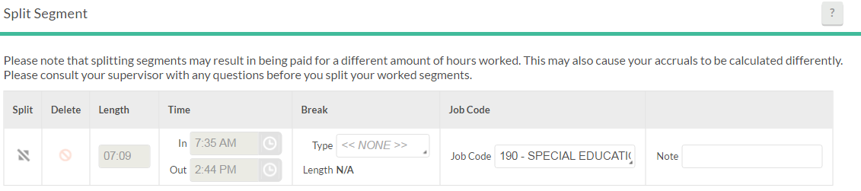

**You can use the split segment option to change your job code if it is incorrect and add notes. You do not need to click the split icon to add additional segments. Click SAVE.**

**APPROVING SEGMENTS**

**Approving segments is the employee’s electronic signature. You are certifying that you have reviewed your hours and they are appropriate and reasonable. If you do not approve your segments, we will not be able to pay you for those unapproved hours. Please review the Payroll Calendar for the deadlines.**

**VIEW | VIEW HOURS:**

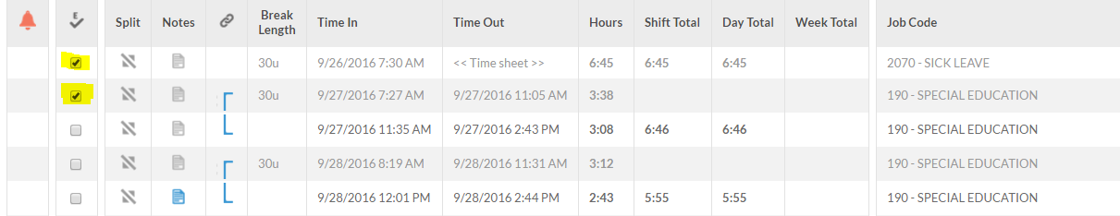

**A check in each box indicates your electronic signature, you can approve segments individually.**

**MANAGE TIME SHEET:**

**You can also approve an entire week at one time. Please note that the Manage Time Sheet option only allows you to go back 7 days.**

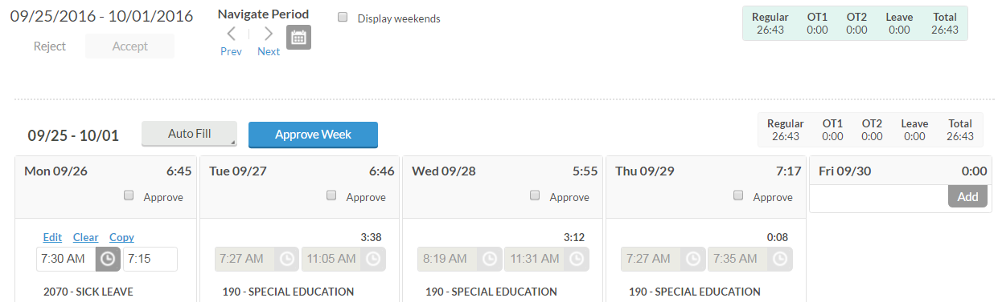

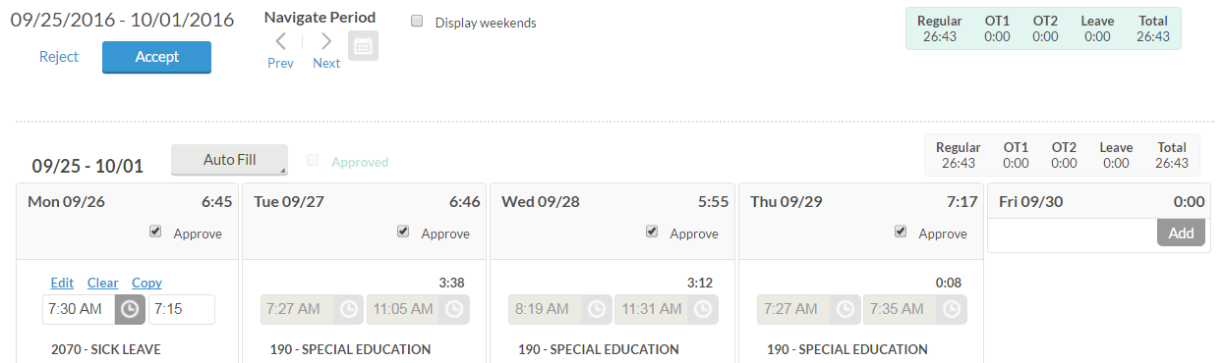

**MISSED PUNCH**

**If you forgot to clock in or out, Time Clock Plus has an option that allows you to manually enter your missed punch time. Please read the instructions carefully.**

**PROXY READER:**

1. Always choose the operation you should normally be clocking on. If you forgot to clock out and you come in the next morning you need to hit clock in just like you would every other morning. The same is true if you forgot to clock in, just click clock out at the end of the day as you normally would.
2. You will get a message that says “Your last clock operation was clock in/out do you want to manually enter your clock in/out time.”
3. Click Yes/Enter
4. Enter the date you were supposed to clock in/out by using the arrows on keys F1-F4 or the number pad
5. Click Yes/Enter to move down to the time
6. Use the key pad to enter the appropriate time in/out, use the up/down arrows to change AM/PM.
7. Click Yes/Enter
8. If you are clocking in and you work multiple jobs it will now prompt you to pick the job you are supposed to clock in on. If you only have one job it will just clock you in automatically.

IMPORTANT: When you forget to clock out the night before and choose to do the missed punch option – the button you choose is CLOCK IN, after you’ve entered the appropriate out information it clocks you in. We have several employees who then try to clock in AGAIN. As part of the missed punch option it is simultaneously clocking you in or out – please do not duplicate this!

**WEB CLOCK:**

**\*Scenario: Employee forgot to punch in when they arrived. At the end of the shift, the employee clicked Clock Out.**

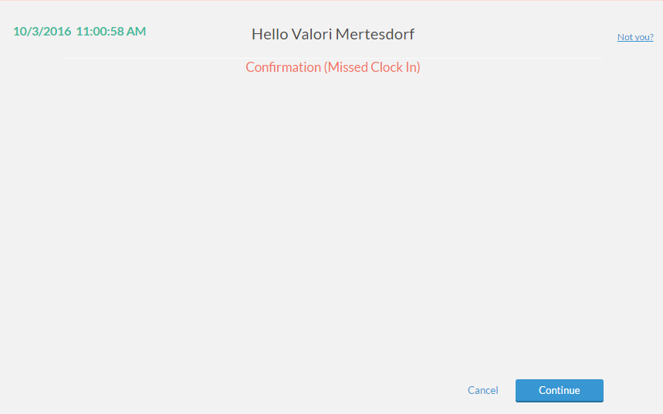

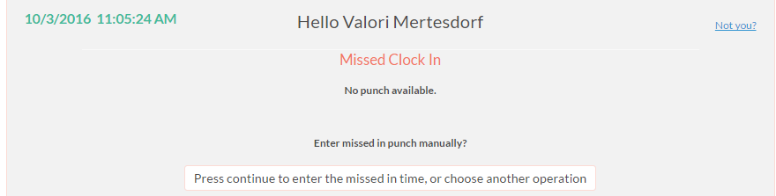

**Click Continue**

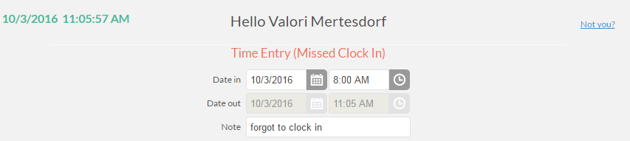

**Employee forgot to clock in, so the clock in is the only part available to enter. The clock out is grayed out because the employee clicked Clock Out to begin this process. Click Continue after entering time and note.**

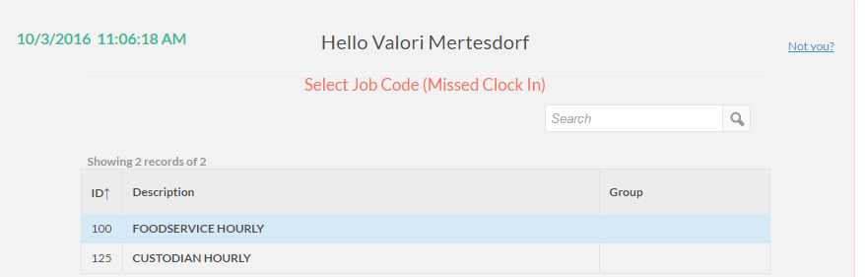

**Select job code if applicable and click continue.**

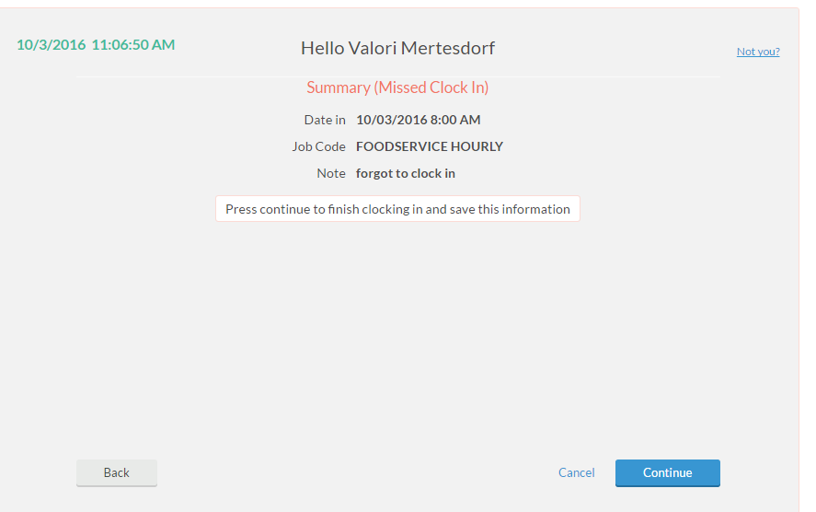 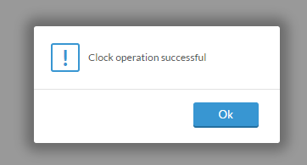

**Please note, after entering your missed in time it simultaneously clocks you out. Please double check your hours before entering it again.**

**Verify the information you entered is correct!**

