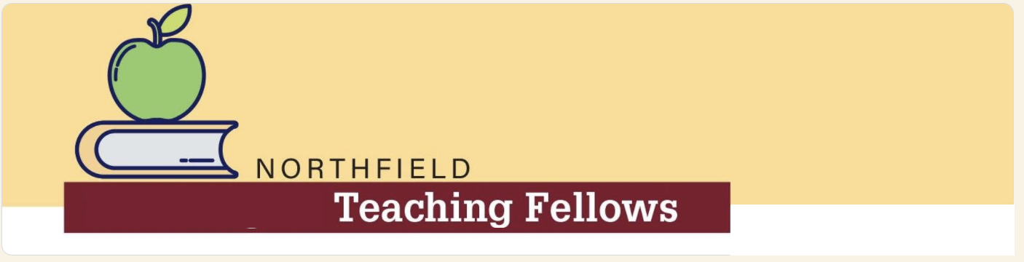
Northfield Teaching Fellows Application
* Round 2 Applications are due by 4:00 p.m. on Monday, April 17, 2023 *

Name:
Address:
Email:
Telephone:

Program Qualifications - Place a check (✔) next to each that applies to you:
I am Black, Indigenous, or a Person of Color (BIPOC) – Required
Must also meet one or more of the following requirements (check all that apply):
I graduated from Northfield Public Schools.
I am a parent of a current Northfield Public Schools student.
I live within the Northfield Public School district boundaries.
I am a current Northfield Public Schools employee.

Please type your answers to the following questions below. You may also submit your responses to Questions 1-4 as a video, if you’d prefer.
- What grade(s) and/or subject(s) do you hope to teach?

- What has led you to want to become a teacher? How do you believe you will be able to help students in this role? (1 page, approximately 500 words; or 2-3 minutes if recorded video)

- Fellows must attend a Minnesota Professional Educator Licensing and Standards Board-approved (PELSB-approved) teacher preparation program (To check whether your planned program is PELSB-approved, please visit: https://mn.gov/pelsb/aspiring-educators/preparation-programs/approved-programs/).

Which PELSB-approved program do you attend or will you be attending? If you do not yet attend one of these programs, please explain your plans to select and enroll in one (we can help, if you need assistance!). As long as you are attending a PELSB-approved program, the decision of which school/program you decide to attend will NOT be factored into your selection as a Fellow.

- While it’s not a requirement for the program, our goal is to help increase the racial and ethnic diversity of the teaching staff in Northfield. Do you hope to return to teach in Northfield someday? Please explain.

5. Do you speak any languages in addition to English? If yes, which one(s)?
Please indicate whether your language levels are conversational, proficient, or fluent in each of the following areas (speaking, reading, and writing):
Specify Language | Speaking | Reading | Writing

Applicants must submit scanned copies of their high school and college transcripts (they can be unofficial copies). If you have not started college yet, just share your high school transcript.

Please send your complete application to teaching@healthycommunityinitiative.org.
Round 2 applications are due by 4:00 p.m. on Monday, April 17, 2023.

