Matthew Holmquist Arts Memorial Scholarship 2023

The Matthew Holmquist Arts Memorial Scholarship will award two separate $1,000 scholarships to graduating seniors of Northfield High School. One scholarship will be awarded to a student who aspires to study music in a four-year college, and one scholarship will be awarded to a student who has aspirations of studying art in a four-year college.

The scholarship is awarded in loving memory of Matthew C. Holmquist, a member of Northfield High School Class of 1999, who passed away unexpectedly in 2021. Matt loved life, and he was a gifted musician and a champion of the arts. As the son of potters and art educators, Matt grew up helping his parents in their studio and traveling with them to art fairs across the country. Matt’s own creative spirit was anchored in music, and he was gifted with a beautiful voice and perfect pitch. In his youth, he performed in the Northfield Youth Choir and earned a position in the esteemed Minnesota All-State Choir. Beyond his voice, he was a gifted performer and took to the stage in high school as Conrad Birdie in Bye, Bye, Birdie, and had multiple solos in the bi-annual Rock and Roll Revival. Music was central to his being, and he continued to write and record music throughout his life.

Matt cared deeply about supporting aspiring young musicians and artists, and this scholarship seeks to honor his memory and extend his legacy.

We encourage all graduating seniors from Northfield High School who have a demonstrated passion for the arts and who aspire to attend college to study music (vocal or instrument performance, music theory, composition, etc.) or art (studio art, painting, ceramics, photography, art education, etc.) to apply. A committee of faculty from the music and art departments at Northfield High School will select the scholarship recipients, and the names of recipients will be featured on a dedicated plaque displayed in Northfield High School.

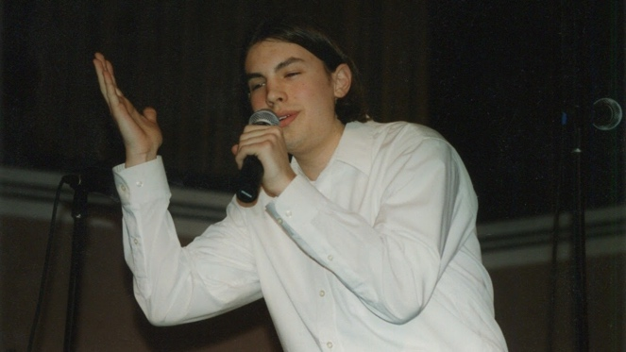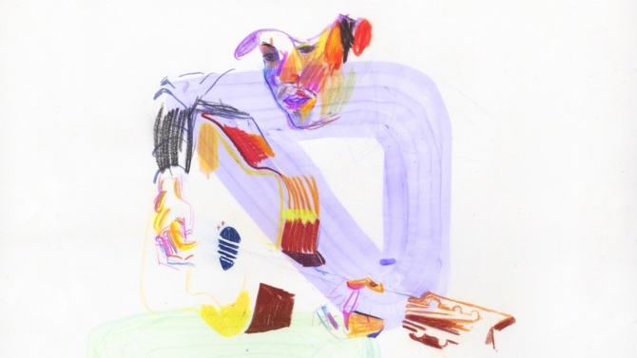

Due Date: Friday, March 24, 2023 in the Counseling Office

If you wish to be considered for this scholarship, please complete the following:

Name:

Email:

Mailing Address:

Phone Number:

Which four-year college do you plan to attend?

If applying for the music scholarship, please describe your musical experience and the school or community ensembles you may have participated in as part of your musical development. Please feel free to highlight the major highlights or accomplishments in your musical career. How will a college education in music shape your career and life goals? Please feel free to attach a separate document.

If applying for the art scholarship, please describe your art experience and the school or community art programs you may have participated in as part of your artistic development. How will a college education in art shape your career and life goals? Please feel free to attach a separate document.

Student Signature ___________________________________

