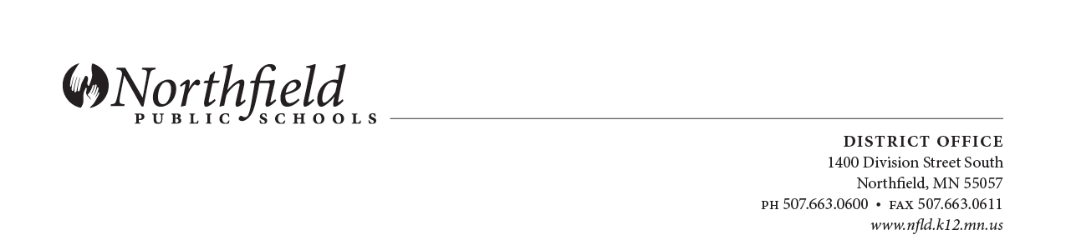
Evaluation for School Social Worker

Name: |  | Date:
Building/Department: | Probationary | Non-Probationary
Position Title: School Social Worker

PROFESSIONAL BEHAVIOR

Attendance: Faithfulness in coming to work on time, as scheduled.

Standard: District employees demonstrate prompt and reliable attendance and are productively engaged while on duty.
NA
Below Standard Meets Standard Exceeds Standard
(Please mark a box on this continuum)
Comments:

- Promoting a Professional Attitude and Culture: The way in which an individual expresses oneself and demonstrates professional behavior at the workplace.

Standard: District employees demonstrate behaviors that support colleagues and contribute to a professional work environment. They accept responsibility and work within the boundaries of job expectations. They are courteous, pleasant, and honest in their interactions with others.
NA
Below Standard Meets Standard Exceeds Standard
(Please mark a box on this continuum)
Comments:

- Communication: Written, verbal, non-verbal, and listening skills.

Standard: District employees communicate in an accurate, cordial and effective manner; maintaining confidentiality and functioning as public relations ambassadors to the community.
NA
Below Standard Meets Standard Exceeds Standard
(Please mark a box on this continuum)
Comments:

- Adaptability and Flexibility: The ability to adjust to changing situations and maintain professional demeanor under pressure.

Standard: District Employees adapt to changing work situations, learn from previous experiences, and tolerate reasonable work pressures in a professional manner.
NA
Below Standard Meets Standard Exceeds Standard
(Please mark a box on this continuum)
Comments:

- Prioritization, Organization and Time Management: The productive use of time during the work day, the ability to prioritize tasks and work efficiently.

Standard: District employees are able to prioritize workloads, complete tasks on time, follow through without reminders, and work efficiently by utilizing existing resources.
NA
Below Standard Meets Standard Exceeds Standard
(Please mark a box on this continuum)
Comments:

- Professional Appearance and Workspace: Personal cleanliness, appropriate dress, and a safe, orderly work environment.

Standard: District employees dress appropriately for their positions, maintain personal cleanliness, and keep their work environments clean and safe.
NA
Below Standard Meets Standard Exceeds Standard
(Please mark a box on this continuum)
Comments:

JOB SKILLS

A. Provides direct and indirect social work services as a related service in support of the instructional goals for students with Individual Education Program (IEP) plans.

1) Provides direct services to students as specified in students’ IEPs, including: individual counseling, group counseling, social skills training and behavior management.
NA
Below Standard Meets Standard Exceeds Standard
(Please mark a box on this continuum)
Comments:

2) Provides information and assistance to families to help them understand their child’s educational disability and equip them with the tools necessary to support their child’s educational and/or behavioral progress. Provides parent training and support as needed.
NA
Below Standard Meets Standard Exceeds Standard
Comments:

3) Provides consultation to school staff in developing and implementing interventions to allow students to be successful within the mainstream.
NA
Below Standard Meets Standard Exceeds Standard
Comments:

B. Acts as a liaison between the home, school and community providers to access, mobilize and coordinate services for students who have an IEP.

1) Communicates with staff, administration and parents concerning students’ social, emotional and behavioral progress.
NA
Below Standard Meets Standard Exceeds Standard
Comments:

2) Provides information to students and parents about services available within the community. Makes referrals to community providers, as appropriate.
NA
Below Standard Meets Standard Exceeds Standard
(Please mark a box on this continuum)
Comments:

3) Consults and collaborates with social services, mental health and other community providers.
NA
Below Standard Meets Standard Exceeds Standard
(Please mark a box on this continuum)
Comments:

C. Functions as a member of the building-level special education team in providing special education services to students with disabilities

1) Provides information to parents regarding the referral/assessment process, special education services available within the district, and their rights relative to special education.
NA
Below Standard Meets Standard Exceeds Standard
(Please mark a box on this continuum)
Comments:

2) Assists school staff in developing and implementing interventions designed to resolve students’ academic and behavioral problems.
NA
Below Standard Meets Standard Exceeds Standard
(Please mark a box on this continuum)
Comments:

3) Functions as a member of the building-level Student Assistance and Special Education Referral Teams.
NA
Below Standard Meets Standard Exceeds Standard
(Please mark a box on this continuum)
Comments:

4) Conducts social/developmental assessments of students referred for special education, assists in determining eligibility for special education.
NA
Below Standard Meets Standard Exceeds Standard
(Please mark a box on this continuum)
Comments:

5) Maintains an accurate record of student, parent and other contacts.
NA
Below Standard Meets Standard Exceeds Standard
(Please mark a box on this continuum)
Comments:

D. Provides crisis intervention services as needed.

1) Conducts risk assessments.
NA
Below Standard Meets Standard Exceeds Standard
(Please mark a box on this continuum)
Comments:

2) Coordinates home, school and community resources in addressing the crisis situation.
NA
Below Standard Meets Standard Exceeds Standard
(Please mark a box on this continuum)
Comments:

3) Coordinates follow-up services as needed.
NA
Below Standard Meets Standard Exceeds Standard
(Please mark a box on this continuum)
Comments:

E. Performs other comparable duties of a like or similar nature as apparent or assigned.

1) Attends training sessions, conferences, seminars, department and district meetings.
NA
Below Standard Meets Standard Exceeds Standard
(Please mark a box on this continuum)
Comments:

2) Serves on District committees, task forces, work groups, etc., as requested.
NA
Below Standard Meets Standard Exceeds Standard
(Please mark a box on this continuum)
Comments:

3) Keeps abreast of changing developments, trends, instructional and educational technologies.
NA
Below Standard Meets Standard Exceeds Standard
(Please mark a box on this continuum)
Comments:

_________________________________________________________________________________

SUMMARY

Major Areas of Strength:

Possible Areas for Growth:

These can be strengthened by doing the following:

General Comments:

Rated by: __________________________ ________________________ __________________
Name of Supervisor Title Date

This report has been discussed with me. My signature below indicates that I have received a copy of it, and not necessarily my agreement with its contents.

____________________________________________ ____________________________________
Employee’s Signature Date

